**EXPERIMENT-10**

**AIM:** To develop PLC Ladder Program using Advanced Instrucions.

**Exercise**:

**Draw a ladder diagram for the problem given below.**

**1)**Set up PLC program to obtain O/P as P in N7:0

P=square(M)+square root(N) :Where M&N are I/Ps

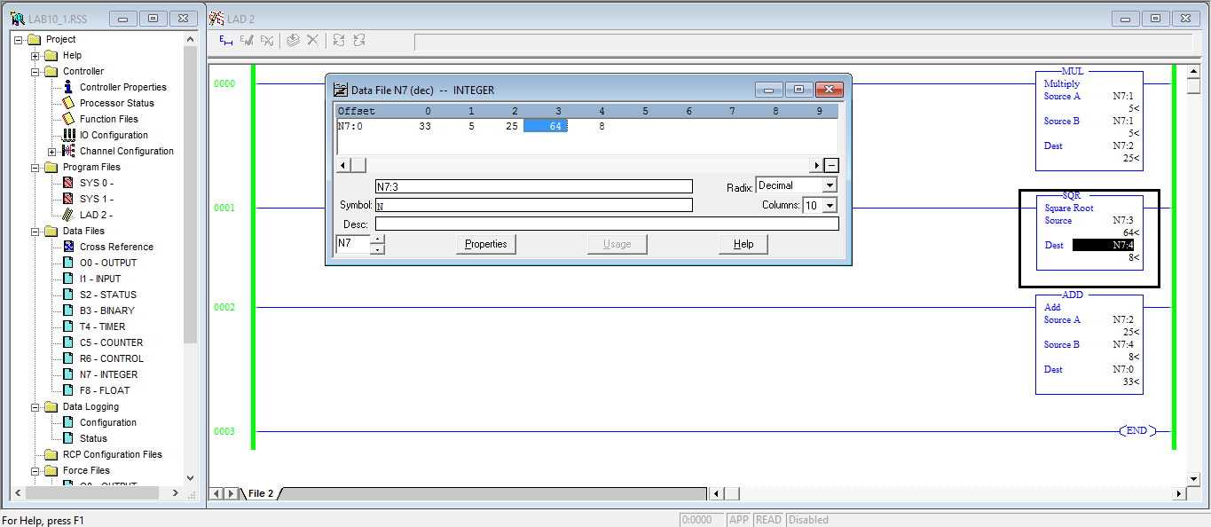

**2)**Degree centigtrate to degree ferenheit conversion.

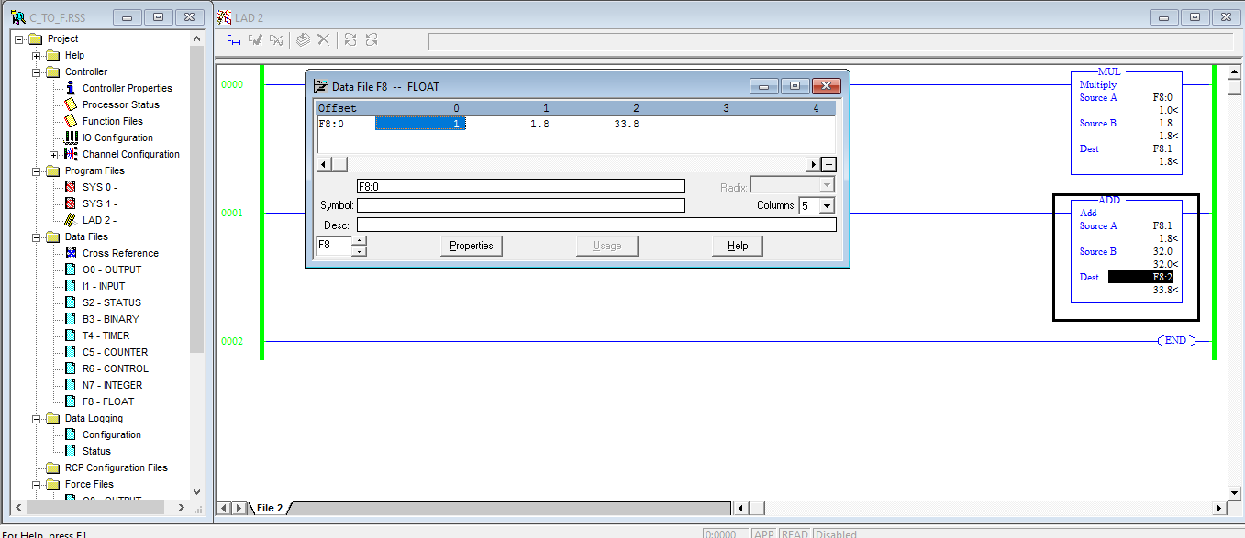

**3)**Find slope of line joining (x1,y1) & (x2,y2).

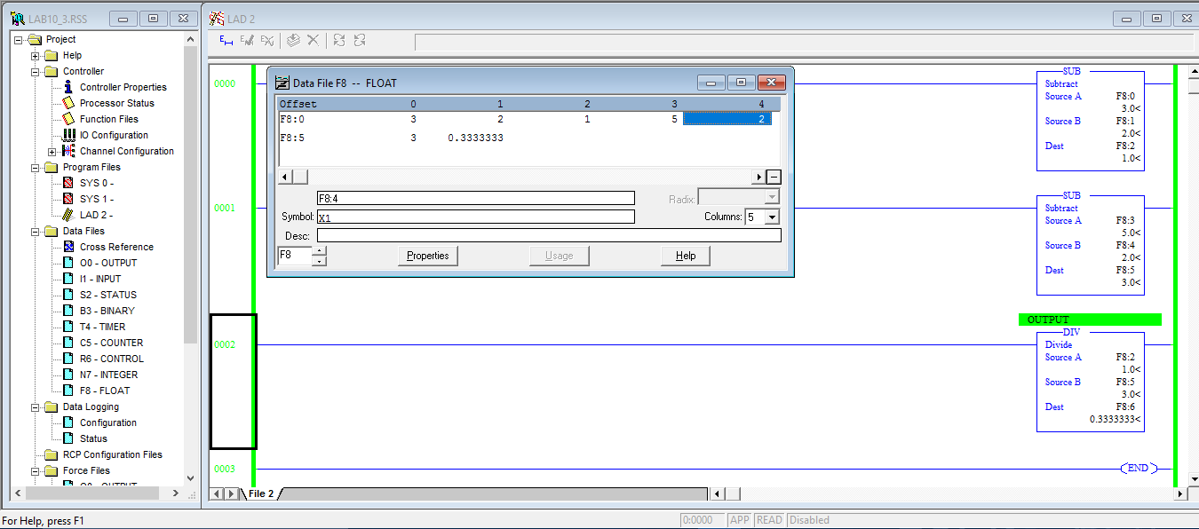

**4)**Two liner I/Ps 0 to 4v are to be multiplied &result put on a linear O/P of 0 to 150v. Make digital ON if analog O/P is between 80 to 150v.

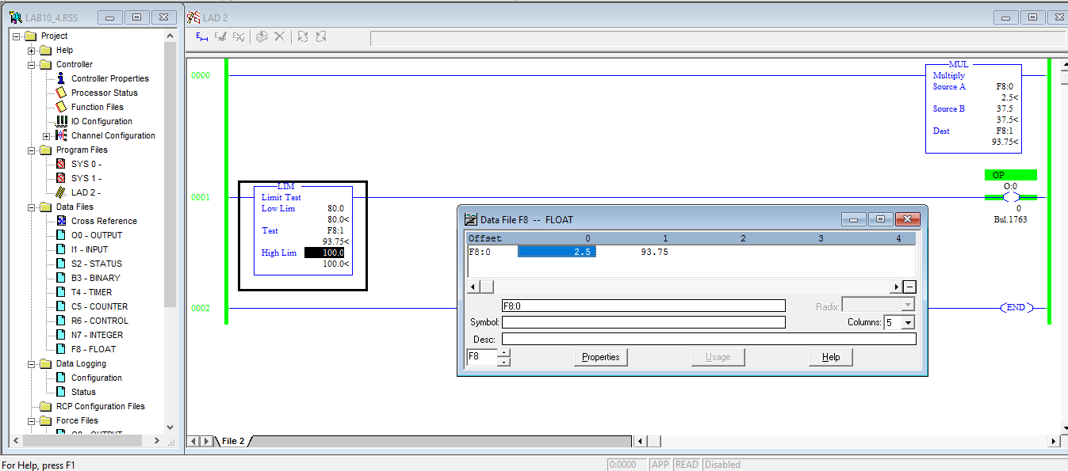

**5)** A temperature control system consist of four thermostats. The system operates three heating units. Thermostats are set at 55, 60, 65, 70 °**C.** Below 55°**C,** three heaters areto be ON. A temperature between 55 and 60°**C** causes two heaters to be ON. For 60 to 65°**C,** one heater is to be ON. Above 70°**C,** there is a safety shutoff for all three heaters. In addition a master switch turns ON and OFF. List out I/P and O/P used clearly with their addresses.

I/O LISTING

START - I:0.0/0 MASTER SWITCH – I:O.O/3 STOP - I:0.0/1

HEATER1 – O:0.0/0 SHUTOFF – O:0.0/3 HEATER2 – O:0.0/1

HEATER2 – O:0.0/2 START BIT – B3:0/0

